*Week 3 (02/09/2020): Second game development discussion*

*Introduction:*

This week’s game development discussion only consisted of 3 students, including myself. The game we came up with is titled Territorial Acquisition Game (TAG). We designed it to suit a tile-based conquest game. Up to 4 players can brawl it out with different game modes. Upon starting the game, each player will spawn at different corners of the map. The objective of the game is to attack other players, claiming as many tiles and destroying other capitols.

*Mechanics:*

We are using a ‘Token Unit System’. This means that each player gains 1 token at the start of each round. Each player will spawn in their ‘Capitol’. As long as the Capitol still stands, it will provide the player with 2 tokens each round. “Troops” are purchased through the spending of a player’s tokens.

Let’s take an example of gameplay between ‘Red’ and ‘Blue’. If it is Red’s turn to conquer a tile that Blue has already been occupying, his troop count would need to surpass that of Blue’s. In hindsight, If Red has 4 troops and Blue has 3 troops, Red would be able to conquer that tile but will be left with 1 remaining troop because 4 subtracted by 3 is equalled to 1. If they have the same amount of troops, a dice will be rolled and whoever has the higher number will win that tile. However, the condition is set so that only 1 troop may advance if this were to occur.

*Rules and how the game functions:*

There are 2 settings in which the players can change before they start engaging. The first would be the map size; the default map size is 10x10. Of course, different maps have their own recommended size. The second would be the number of turns of that game; the default is set at 30 turns. The maximum number of troops that can be stationed on a tile is 5. To add to that, each troop can only move 1 tile per turn. A final addition to the game was for every 3 tiles owned by a player, a bonus token is awarded to them.

*Goals and winning conditions:*

There are several ways to win the game, depending on the type of game mode chosen. 2 examples would be to either conquer all other capitals or have the most amount of tiles secured by the end of the turns.

*Figure 1: Example board*

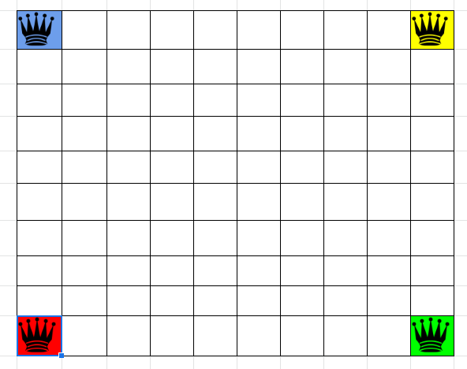

**Figure 1: The above figure shows a basic mock-up of the board that can be implemented into the game**

*Play testing:*

The team carried out an internal testing instead of an external. Since there was only 3 of us discussing, most of the time was spent on brainstorming an idea. Designing and setting up other variables made it so that we had less time to play test our ideas with other groups. In the end we resulted in internal testing. During the testing phase, we managed to scope out a few issues with our game. It is rather difficult to keep track of how many tokens and units each player has at the moment. To counteract this, a layout or GUI should be implemented to show the players this information.

*Figure 2: Testing board*

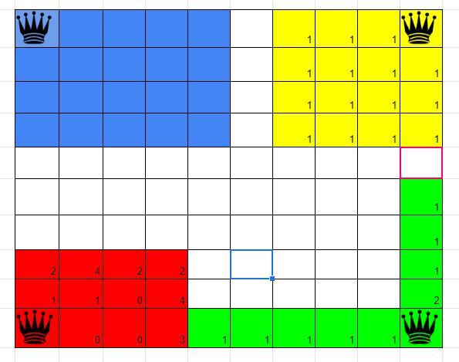

**Figure 2: The above figure shows a brief and vague example of how the game would play out with 4 players**